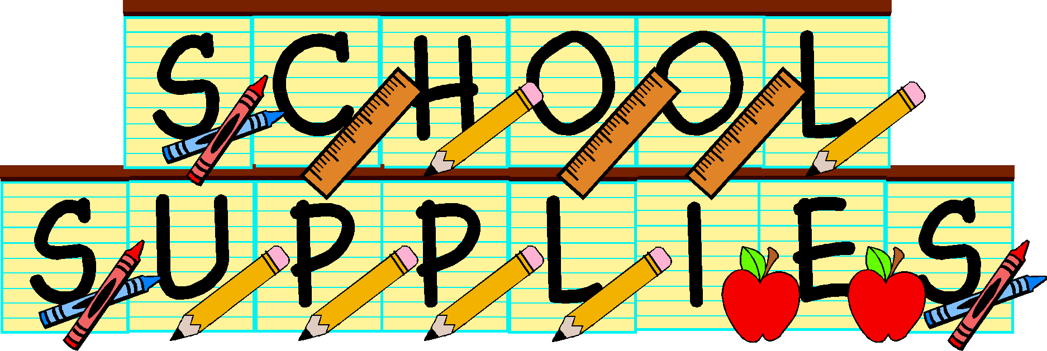

List of school supplies for 3H:
(4) boxes of sharpened pencils
(4) large erasers
(1) non-electric personal pencil sharpener
(1) Pencil Box
The following works fine and is just the right size: https://www.amazon.com/Sterilite-Plastic-Pencil-Box-17234812/dp/B004400KLG
(1) black Sharpie marker
(3) colored folders:
-red
-green
-dark blue
(1) box of Kleenex
(1) roll of paper towels
Wish List Items:
Clorox (or any brand cleaning wipes)
Thick Dry Erase markers
Spray cleaner such as Windex or Fantastic
Hand Soap

